https://leetcode.com/problems/count-the-digits-that-divide-a-number/submissions/2191383085/

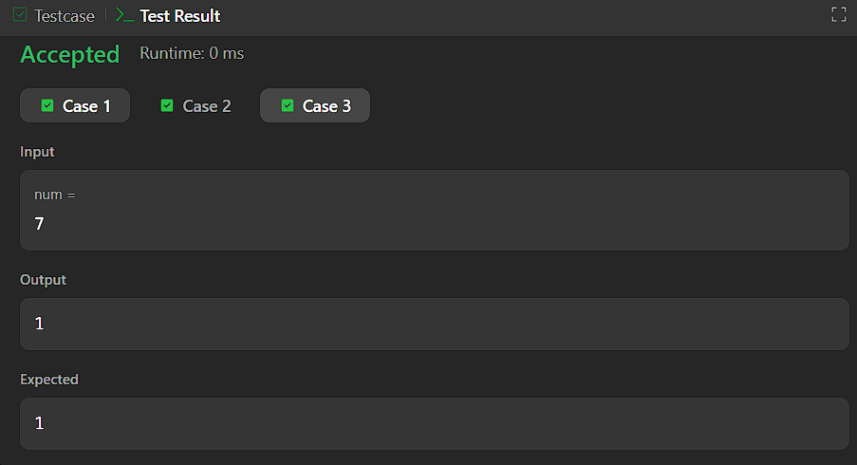


CODE:

int countDigits(int num) {
int count = 0;
int temp = num;

while (temp > 0) {
int d = temp % 10;
if (num % d == 0) {
count++;
}
temp /= 10;
}

return count;
}

